ULTRA ISOLATION TRANSFORMER

Sophisticated electronics equipment are most sensitive to line transients, spikes and notches. These impulses are of a very short duration of the order of a microsecond to a very few mili seconds but their amplitude can range from hundreds to thousands of volts They can be caused by lightning, mains line switching, air conditioning or switching of goy heavy duty machinery If they are not suppressed they can cause memory loss in computers or scrambled data transmission, overstressed components or even component failure
POWERCON’S ultra Isolation transformer provides effective protection from the line transients. Primary and secondary of the transformer are wound on separate cores multiple shielded and fully isolated from each other and the ground to ensure extremely low inter winding capacitance. It acts as an efficient low pass filter and suppresses line transient’s spikes and galvanic leakage to protect the computer system. Due to total Isolation from the mains line the Isolation Transformer output is extremely safe to handle and is most suitable for medical applications as well It is available in KVA ratings from 10KVA to 1000 KVA Three phase models.

Did you know that most AC power lines are superimposed with dangerous spikes, surges, transients, sags, RFI noise and harmonics?
This is due to Inductive and SMPS loads, electronic ballasts, PWM switching systems, or even improper earthing. Such electrical noise often damages costly Hi-Tech machinery, unduly interrupt factory operations and increase down time resulting in increased expenses. The lack of adequate protection in such environments results in the steady rise of failure rate in such equipments. Isolated power supply has therefore become a necessity in order to prevent such breakdown time and costs.

Ultimate Protection against Electrical Noises
As an Ultra Isolation Transformer, Powercon’s’s Tranquil is the most powerful solution to help eliminate all types of noise, particularly Common Mode Noise, Spikes, Surges and Transient Noise, which act as silent killers inside factories and commercial parks alike.

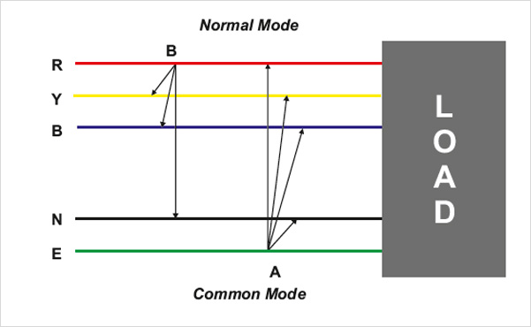.

Designed for Energy Efficiency & Reliable Performance
Tranquil transformers are built to meet the stringent requirements of the most sophisticated equipment being used today, resulting in a clean and noise-free power supply. Each Tranquil is intelligently designed using advanced technologies and proven engineering principles to provide reliable performance and energy efficiency year after year. Furthermore, by completely isolating primary and secondary sides as well as the neutral to ground bond on the secondary side, Tranquil creates a separately derived power source to combat current loops.

Silent features

- Total Protection
- Energy Efficient
- Noise Elimination
- Causes of electrical noise
- Effects of electrical noise
- Effective isolation from the noisy power lines
- Extremely low interwinding capacitance
- Electrostatic shielding capacitance
- High galvanic isolation
- Suppression of common mode & transverse mode noise

TECHNICAL SPECIFICATIONS

Input voltage : 230/415V (acceptable +/- 10 %) 1Ø / 3Ø + Neutral (or as per customers requirement)
Output voltage : 230/415V (same as input 1Ø / 3Ø + Neutral (or as per customers requirement)
Transformer ratio : 1 : 1
System Connections : Delta/Star or Star/Star
Regulation : 2-4%
Power Factor : 0.75 Lead to 0.75 Lag
Dielectric Strength : 3 KV for 60 seconds
Insulation Resistance : > 1000 Mega Ohms (MW)
Leakage Current : < 20 Micro Amps (µA)
Efficiency: > 98%
Insulation Class : F / H
Operating Temperature: 0°C to 50°C

RATING

Supply System | Input Voltage* | Output Voltage* | Ratings (KVA)
Three phase | 415V | 380V/415V | 10, 15, 20, 25, 30,  40, 50, 60, 75, 85,  100, 125, 150,  200, 250 KVA
Three phase | 415V | 200V/220V | 10, 15, 20, 25, 30,  40, 50, 60, 75, 85,  100, 125, 150,  200, 250 KVA

Note : Customizable voltages also available.

Applications

- CNC & Hi-tech Machines
- Large Computer Installations
- Printing Machinery & Presses
- Textiles & Garments Manufacturing Machines
- Bio-Medical, Pharmaceutical and Hospital Equipment
- Equipment at Oil & Gas Refineries and Power Plants
- Telecom & Mobile Network Equipment and more
- For preventing data corruption and failure in computers using hard disc
- For the protection of telecommunication and data communication equipment
- For the patient's safety while using machines like ECG. EEG or EMG Pacemakers of
Any electrosurgical ald
- For clear recording in audio and video recording equipment
- For error free data In process control Instruments
- For elimination of earthling problem in computer Installation
- For Protection of CNC/PLC equipment from surges / spikes

